My Pouch Easy Fix Guide

When you upload your artwork to the website, you might come across one, or a few error messages. These are really simple to fix, so follow this guide to find the error you might be facing and make amendments to get straight back to completing your order!

X Colour Missing
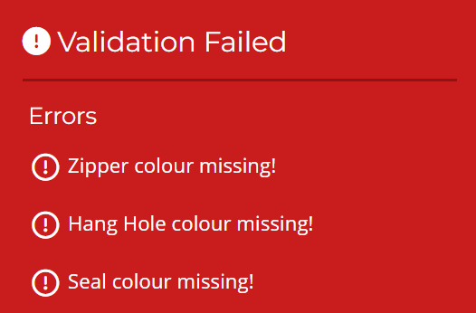

One of the main issues you may face is that when you upload you artwork, it tells you, for example, that seal colour is missing. What this means, is that the seal layer you have selected on the configurator, is not showing on the artwork. However, this is not just for seal colour, this could be and including all features that you can select on the configurator. Below is a list of all error messages of these types that you can face when uploading your artwork;
- Seal Colour Missing
- Zipper Colour Missing
- One Way Valve Colour Missing
- Hang Hole Colour Missing
- Corners Colour Missing
- Tear Notch Colour Missing
To Fix: Simply go back into your artwork file on illustrator, turn on the layers that show the error message (that you have selected on the configurator), and reupload! Hopefully this should now solve your problem!

X colour in document art - not selected in product
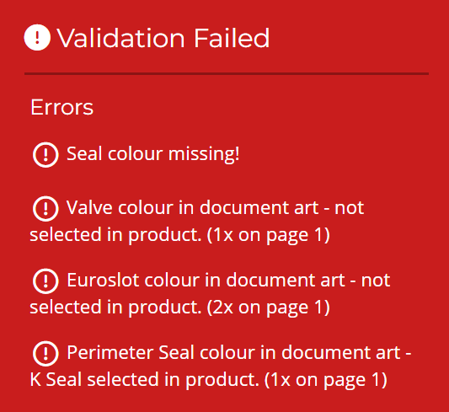

This issue is the opposite of the issue above. This means that in your illustrator file you have a layer turned on, however on the configurator it is not selected. So for example, in your artwork you have a euroslot, however on the configurator, you have selected no hang hole.
- Euroslot colour in document art - not selected in product.
- Tear Notch colour in document art – not selected in product.
- Perimiter Seal colour in document art - K Seal selected in product.
To Fix: Either, on the configurator select the right options that are on your artwork, or go into your illustrator file and turn on the correct layers and turn off the layers that you don’t want, and then reupload your artwork!

Incorrect template size
This issue is quite simple; it means that the artwork you have just uploaded is the wrong size that you have selected in the configurator. The example below shows what happens when you upload a size 2 pouch when you have selected size 1.
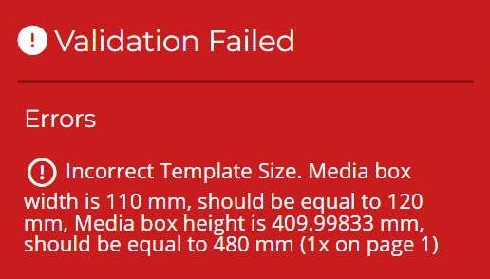

- Incorrect Template Size. Media box width is 119.99983 mm, should be equal to 110 mm, Media box height is 480.00003 mm, should be equal to 410 mm
To Fix: Either select the size of the template you have uploaded or download the correct size cutter template you need and reapply your artwork, and turn on the correct feature layers!

